 | Copeland Canoe Club | 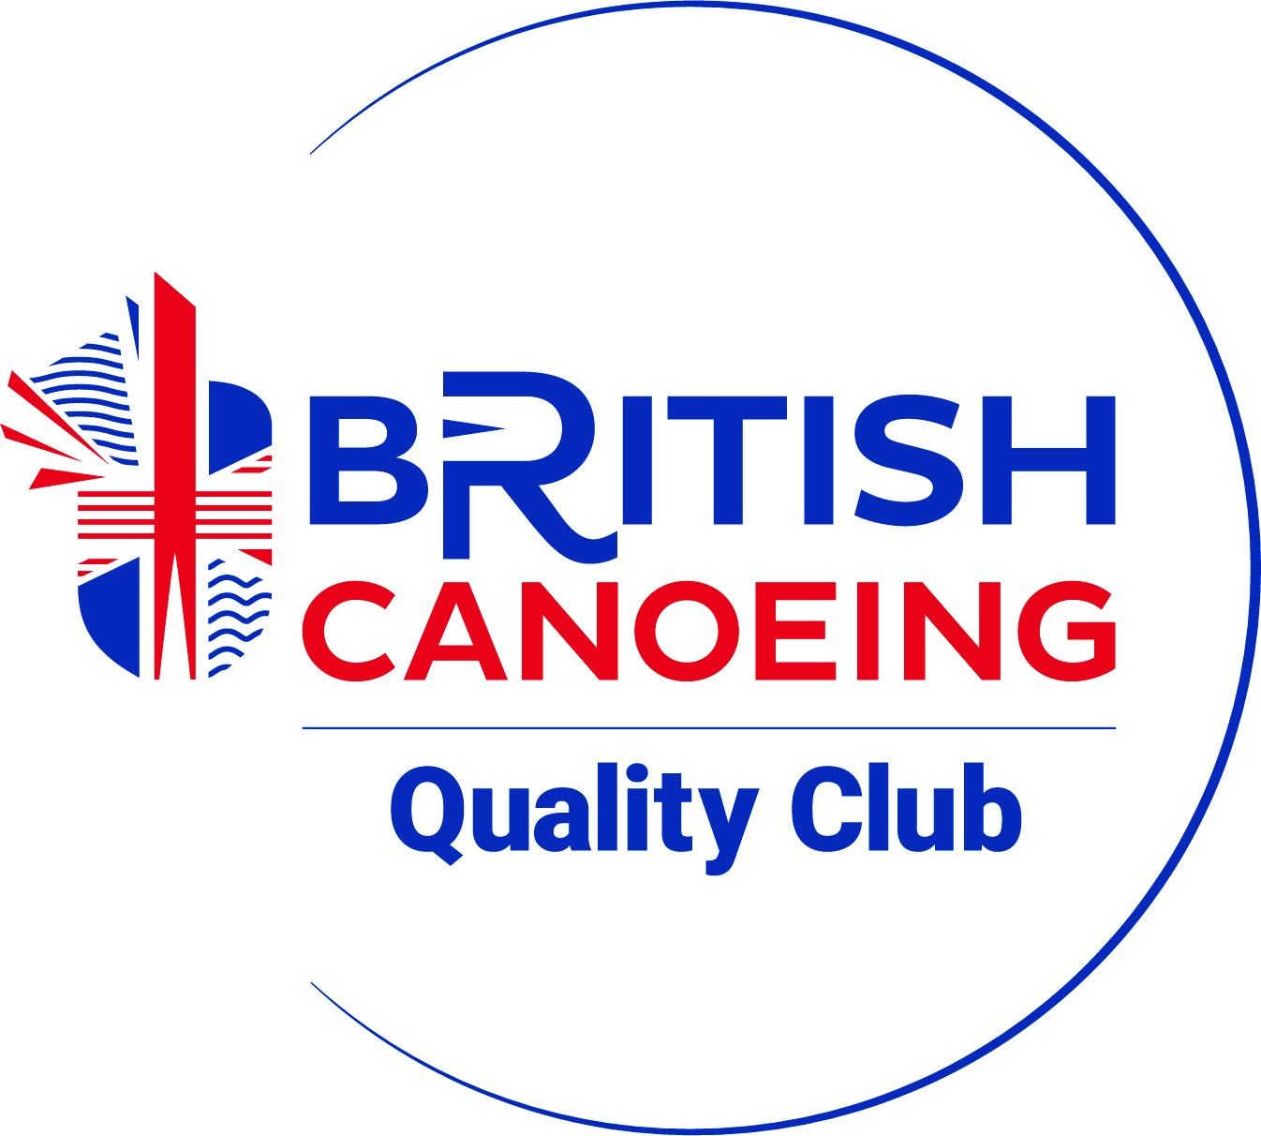

Annual Club Meeting 20.11.2024 - Minutes

Venue: Whitehaven Harbour Youth Project CA28 7LZ Start: 19:00

Welcome from Mark Jones
Present: Keith Rhodes, Stephen Walter, Isla Price-Walter, David Topliss, Paul Bailey, Barry Allan, Ryan Garner, Mark Jones, Bob Frazer, Alison Bird, Andy Bennion, Jan Stalker, Joe Stalker, Rob Stalker, Rich Stalker, Ross Cleeton, Erin Cleeton, Simon Kay, Estelle Kay, Jenson Skillen, Tina , Al Yates. (22)
Apologies: Tony Foster, Jon Cheesewright. (2)

Agenda –
Chair Comments:
Thank you all for your continued support to the club, whether a committee member, volunteer or parent doing the transporting – all help is appreciated.
We achieved the British Canoeing Quality club re -accreditation in Oct. Opportunity to refresh and demonstrate our club operating procedures against recognised standards etc. Thank you to Bob for leading on this.
We ran the 18th annual Sea Quest event in June over the three estuaries at Ravenglass with over 109 competitors taking part. The event raised £887 with the proceeds going to the Wasdale Mountain Rescue. We already have interest from groups looking to attend next year’s event on 13th July. Camping on the Sat night prior to the event worked well.
We have seen a steady rate in members over the last 12 months to around 105 members, compared with 102 last year – We have seen 24 new members this year off set with 21 not re-joining which is a steady trend over the years.
The club continues to run a summer and winter programme of trips to cater for all levels of kayaking across rivers, lakes and sea paddling. Numbers attending the summer Tues evening programme were low compared to previous years, do we understand why? Survey ??
Our pool sessions have recently restarted over the winter months and is an area of continued focus as is our main expenditure and ensuring we provide what our members want – play, skills and development in a safe environment – Thanks to Alison for leading on this.
We can have a discussion within the treasurer report around pool fees and annual club membership fees. These have remained the same for a number of years at Under 18 / over 60 - £17 (£20) propose £20, Senior £23 (£30) propose £26, Family £34 (£50) propose £38. Leave pool fees for time being.
The club sea kayak weekend sessions to Farne Island / Mull of Galloway were well attended, we are looking at putting a programme together for 2025.
We also supported for the third year the St Bees Seafest in July where we provided kayak and SUP taster sessions.
Slalom has been popular within the club with members from Junior level upwards participating in a number of events, across Div 1, div 2 and div 3. The club also supported a recent event on the Leven.
Several coaches / members have led and attended the Cumbria Canoeist sea kayaking events over the last year. We have a number of new and active coaches which is helping to spread the load across the volunteer network.
The club has been successful in securing a grant this year for training and development, which has enabled a significant plan to be put in place to achieve the following:-
- Paddle sport safety and rescue – 7.
- White Water safety and Rescue – 7.
- Paddlesport Instructor – 2 – Training and assessment to follow in March.
- Paddlesport Leader training – 6. – Assessments to follow.
- Paddlesport touring leader training – 1 – assessment to follow.
- White Water Leader training – 4 – assessment to follow.
Assessment dates available – 22nd Feb, 1st March, 8th March, 15th March. Me / Bob and Paul will work through the plan.
A thank you to Bob for leading on this, and all those who have and continue to give their time for their and the club’s development / future sustainment.
I would also like to thank Jan for stepping into the Treasurer role and Tony – it’s been a seamless transition.
Looking forward over the next 12 months, areas of focus remain on:-
- Coach and members development / retain / recruit as a priority.
- Continue to provide structured training / event plan for the sessions to align club activities to members’ needs, development and wide varied activities.
- Focus on the pool structure to meet what members want. Worth a discussion with other clubs / PUK for ideas etc.
- Continue to have fun in a safe environment!
The success of our club and thanks is down to the support we get through the committee members, coaches, volunteers and parents who have and continue to support the club which is recognised and very much appreciated.
Also have CPD live event full day– Newby Bridge Ulverston – 25th Jan – mix of sea kayak workshop, SUP workshop, river coaching skills, open boat workshop. Let me know if interested.
Mark: Club Chairman
Treasurer’s Report: See separate list from Jan. Many thanks to Jan for taking over - acclaimed by the meeting.

Secretary’s Report
Club stuff
- Usual letters /emails re Ennerdale use, affiliation etc. Only a few letters these days!
- Garage – we now don’t pay rates on it, only the annual ground rent to the council.
- Pool dates – end 2024 is 10 Dec, start in 2025 is 14 Jan, last pool is 13 May. Restart 9 Sep?
- Outside trip Tuesdays start 20 May, end 31 Aug.
- Dates for Christmas 25/26 to sort yet!
Accreditation by BC – Bob has sorted this, Quality Club continuing. Many thanks to Bob for this!
Affiliation to PUK (was BC): Annually at end October. Numbers breakdown /cost:
2024 |  | Total: | 105 | as of ... |  | 19/11/2024
Numbers: | BC members |  | Non-members |  | Total | Adult Cap | U18 Cap
Ages | M | F | M | F | (M+F) | £2.20 | £1.20
U14 | 0 | 0 | 15 | 10 | 25 |  | 25
14-18 | 2 | 0 | 5 | 8 | 15 |  | 13
All U18 | 2 | 0 | 20 | 18 | 40
19-25 | 2 | 0 | 4 | 1 | 7 | 5
26-45* | 4 | 2 | 6 | 4 | 16 | 10
46+* | 15 | 2 | 15 | 10 | 42 | 25
All adult | 21 | 4 | 25 | 15 | 65
Totals | 23 | 4 | 45 | 33 | 105 | 40 | 38
Final total: | 105 |  |  | Cost: |  | £88.00 | £45.60
* possibly...! |  |  |  | Total: |  | £133.60
Volunteers: | 21 |  |  | Aff fee: |  | £135.00
 |  |  |  | Final total |  | £268.60

We pay a standard £135 plus a capitation fee for non-PUK (BC) members. This covers insurance for members (who aren’t individual PUK members) on club activities only.
Costs previously (club affiliation fees have not changed since 2012):
2023: £288.80, 2022: £275, 2021: £237.20. The actual fee depends not just on numbers but also their ages.

The Outdoor Partnership
We are affiliated to TOP. Cost £140/year. Unlocks £500 / year funding for training, etc. Also advice for funding. Next meeting, Jan 2025.

Many thanks to all for your support this year!
AY, 20.11.2024
Discussions on matters arising from the reports
Membership and pool fees: Meeting agreed the following for 2025:
Under 18 / over 60 - £20, Senior >18 £26, Family £38. Leave pool fees for time being.
- Next meeting – AGM November 2025
Meeting finished 21:00 (approx!): AY

